**4-Hour Workshop on Architecting E-Commerce with .NET & Azure Cloud: Leveraging AI and Advanced Azure Services**

I’m excited to share that I recently had the opportunity to conduct a 4-hour workshop focused on Architecting E-Commerce Solutions with .NET and Azure Cloud, enriched by AI-driven capabilities using Azure OpenAI and Azure Cognitive Services. This workshop aimed to provide professionals in the e-commerce domain with hands-on insights into designing scalable, secure, and intelligent platforms that not only meet business goals but also enhance the customer experience with advanced AI techniques.

As an Enterprise Architect and .NET Solution Architect with over 18 years of experience, my goal was to not only share architectural patterns and best practices but also to highlight how AI and Azure Cognitive Services can revolutionize e-commerce platforms.

**Stakeholders Joined:**

**CIO/CTO** for ROI, Security, Resilience (Highlighted cost savings, uptime, and agility)

**CFO**- Budget impact, Cost optimization (Shown FinOps savings & long-term ROI)

**IT Director/VP**- Discussed about Migration risks, Skills gap, Provide phased approach & training plan

**Compliance Team**-Data security, Regulatory adherence, Map Azure services to compliance needs

**Business Leaders**-Customer impact, Go-to-market speed (Show competitive advantages of cloud adoption

**Agenda Breakdown**

1. **Introduction to E-Commerce Architecture:** A brief overview of modern e-commerce platform needs.
2. **Deep Dive into .NET Core and Microservices:** How to structure an e-commerce platform with .NET Core using microservices architecture.
3. **Leveraging Azure Cloud Services:** Discuss Azure services like AKS (Azure Kubernetes Service), Cosmos DB, Azure Functions, APIM (API Management), Azure App Services, and Azure Logic Apps.
4. **AI-Driven Solutions for E-Commerce:** Using Azure AI to personalize customer experiences, automate product recommendations, and optimize business processes.
5. **Cost Optimization with Azure:** Highlight how Azure’s pay-as-you-go model and services like Azure DevOps and Azure Automation help lower infrastructure and operational costs.

|  |  |
| --- | --- |
| **Strategy** | 6R migration strategies (Rehost, Refactor, Rearchitect, Rebuild, Replace, Retire),Azure Migrate, Landing Zones, governance best practices, and cost analysis, Azure Arc, ExpressRoute, VPN Gateway, hybrid identity with Azure AD Connect. |
| **security-** | Azure Security Center, Microsoft Defender for Cloud, Azure AD, RBAC, encryption, and compliance (GDPR, ISO 27001, SOC 2), risk management approach  Azure Key vault, |
| **Governance, and compliance.** |  |
| **Architecture framework** |  |
| **Business Alignment** |  |
| **scalability,** |  |
| **cost** |  |
| **optimization,** |  |

| Category | Topics to Cover | Action Plan |
| --- | --- | --- |
| Strategy | - 6R Migration Strategies (Rehost, Refactor, Rearchitect, Rebuild, Replace, Retire) | - Learn definitions and use cases for each migration strategy.  - Compare Rehost vs. Rearchitect for cost and scalability. |
|  | - Azure Migrate & Landing Zones | - Explore Azure Migrate tool for discovery and assessment.  - Learn Landing Zone architecture for governance and scalability. |
|  | - Governance best practices | - Read Azure Governance documentation (RBAC, Blueprints, Policy). |
|  | - Cost Analysis & Optimization | - Study Azure Cost Management for right-sizing, reserved instances, and autoscaling.  - Use Azure Calculator to compare pricing for different workloads. |
|  | - Hybrid Connectivity: Azure Arc, ExpressRoute, VPN Gateway | - Learn when to use Azure Arc vs. ExpressRoute.  - Understand VPN Gateway vs. ExpressRoute for hybrid cloud. |
|  | - Hybrid Identity: Azure AD Connect | - Study SSO, MFA, Conditional Access, Hybrid AD Join. |
| Security | - Azure Security Center & Microsoft Defender for Cloud | - Learn cloud security posture management (CSPM) and best practices for securing Azure workloads. |
|  | - Azure AD, RBAC, Encryption | - Understand RBAC (Role-Based Access Control) vs. ABAC (Attribute-Based Access Control).  - Study Key Vault for secrets management and disk encryption. |
|  | - Compliance: GDPR, ISO 27001, SOC 2 | - Learn how to ensure cloud solutions meet compliance requirements.  - Explore Azure Policy for governance enforcement. |
|  | - Risk Management Approach | - Learn STRIDE threat modeling and risk assessment frameworks. |
|  | - Azure Key Vault | - Hands-on with Key Vault for certificates, secrets, and keys management. |
| Governance & Compliance | - Azure Governance, Policies, and Blueprints | - Understand governance structure in large enterprises.  - Learn Azure Resource Locks and Management Groups. |
| Architecture Framework | - TOGAF, Well-Architected Framework | - Study Azure Well-Architected Framework pillars: Reliability, Security, Cost Optimization, Operational Excellence, Performance Efficiency. |
| Business Alignment | - Aligning IT strategy with Business Goals | - Learn how to justify technology decisions for business impact. |
| Scalability | - Horizontal vs. Vertical Scaling | - Study Load Balancers, Auto-scaling, and Azure Front Door. |
| Cost Optimization | - FinOps & Cost Reduction Strategies | - Learn how to optimize cloud spend using Reserved Instances, Spot VMs, Serverless compu |

**Key Takeaways from the Workshop**

1. E-Commerce Architecture in the Cloud: The core of any e-commerce platform lies in a robust architecture. In the first hour, I covered the following foundational aspects:
   * Microservices-based Architecture using .NET Core and Azure Kubernetes Service (AKS).

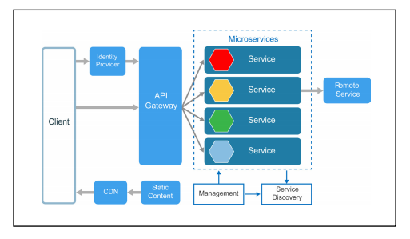

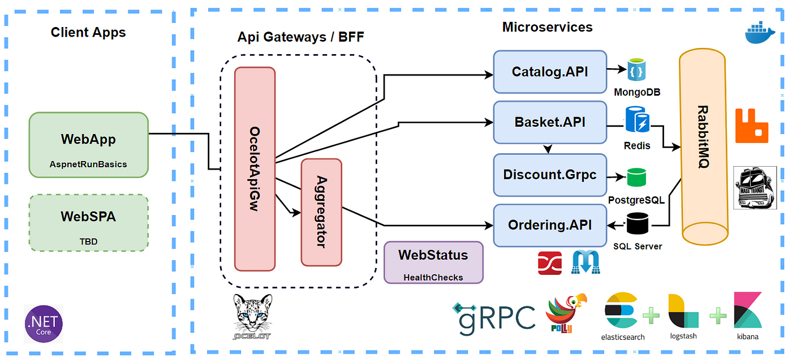

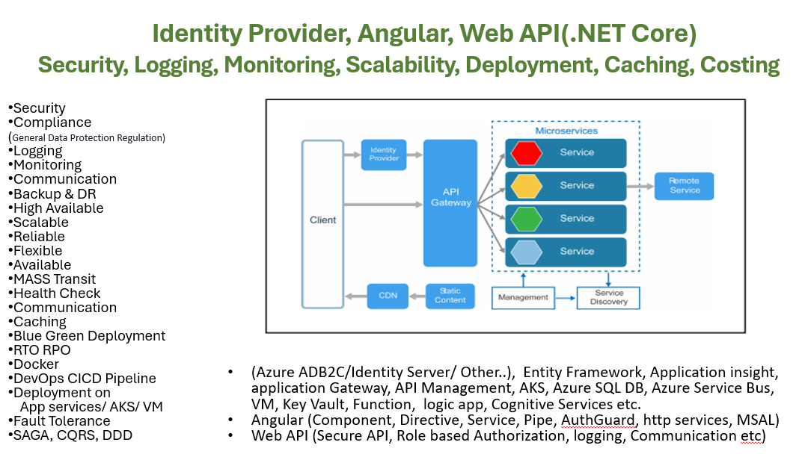

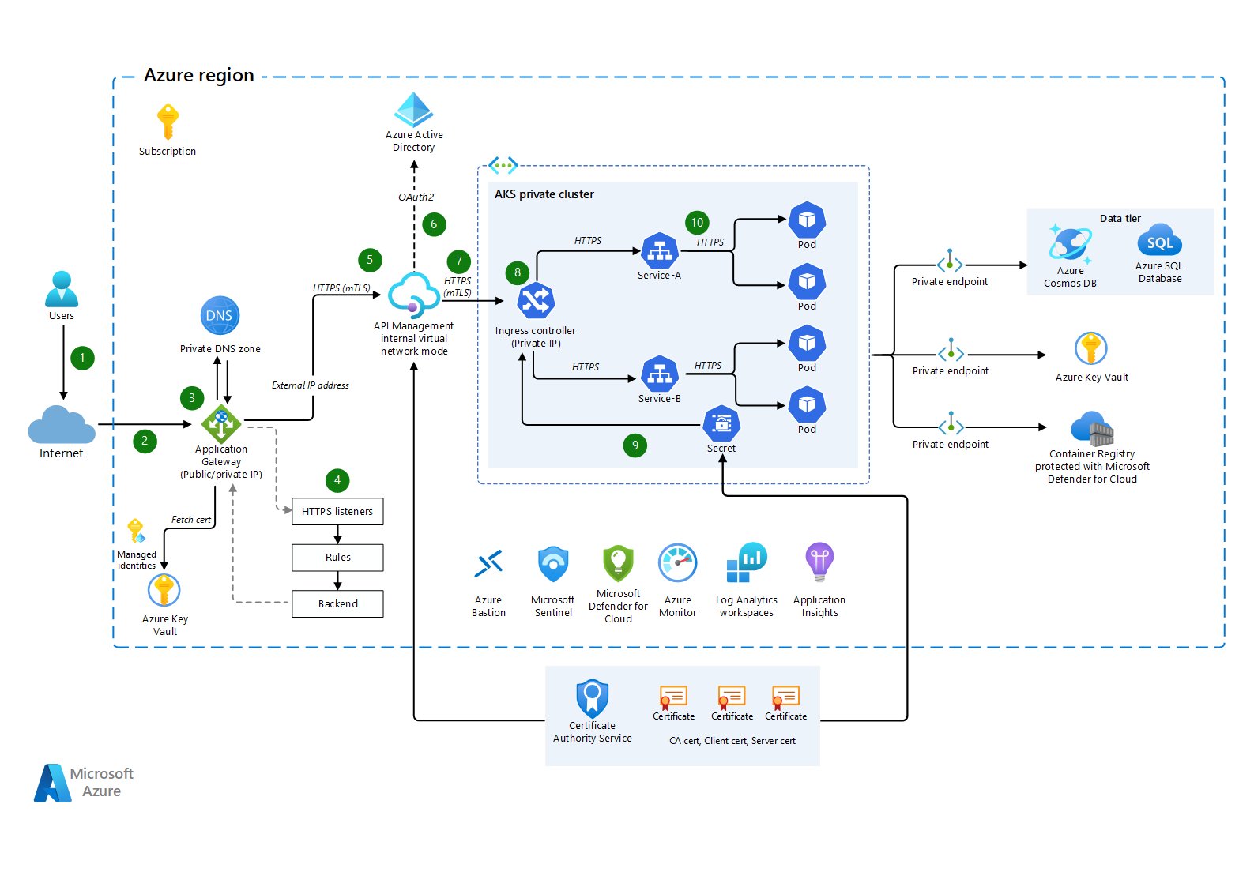

1. 12 Factor Microservice Rule

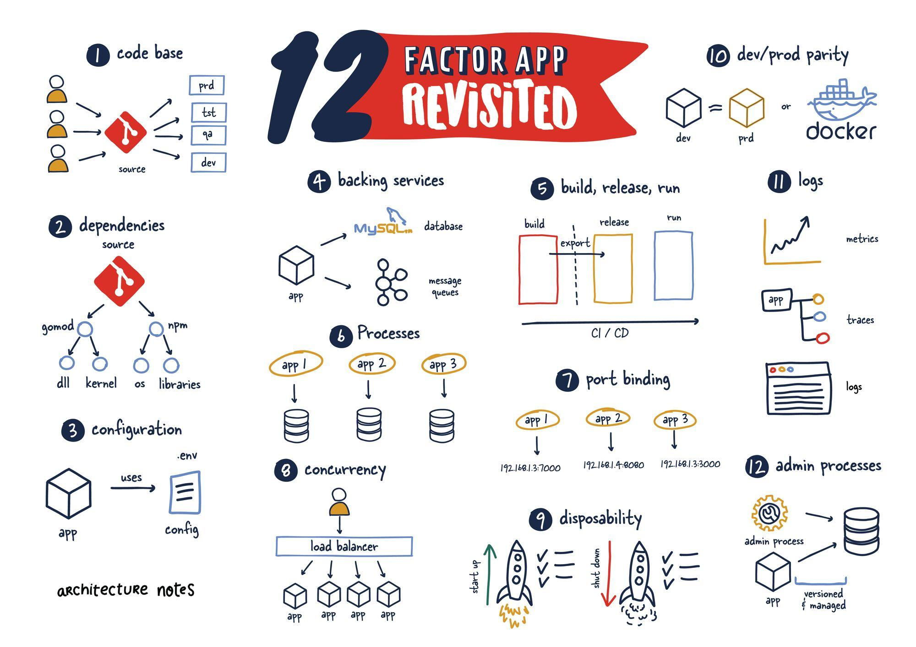

1. Authentication and Authorization, Encryption ( IdentityServer, OAuth 2.0, JWT), SSL/TLS
2. API Gateway (Ocelot, Azure API Management)
3. Logging and Monitoring (ELK Stack (Elasticsearch, Logstash, Kibana)/ New Relic, Azure application Insight, log Analytics
4. Service Discovery (Consule, Kubernetes Services)
5. Fault Tolerance(Circuit Breakers-Polly, retries, timeouts)
6. Database Scaling (sharding, replication)
7. Load Balancing-Kubernetes Ingress Controllers, Azure load balancer
8. Distributed Tracing (Application Insights, OpenTelemetry)
9. Autoscaling (Kubernetes Horizontal Pod Auto scaler (HPA)
10. Microservices Communication- RESTful APIs, gRPC, Messaging Queues (RabbitMQ, Kafka)
11. Health Checks - Kubernetes Probes, ASP.NET Core Health Checks, Consul Health Checks
12. Containerization(Docker, Docker Swarm),Orchestration – Kubernetes
13. Continuous Integration/Continuous DeploymentCI/CD) -Jenkins, Github, Azure DevOps
14. Infrastructure as Code (IaC) – Terraform, ARM Template, Bicep
15. Async, Middleware, SonarQube, Resharper. Code Analysis, Branching Strategy
16. Azure Batch Jobs

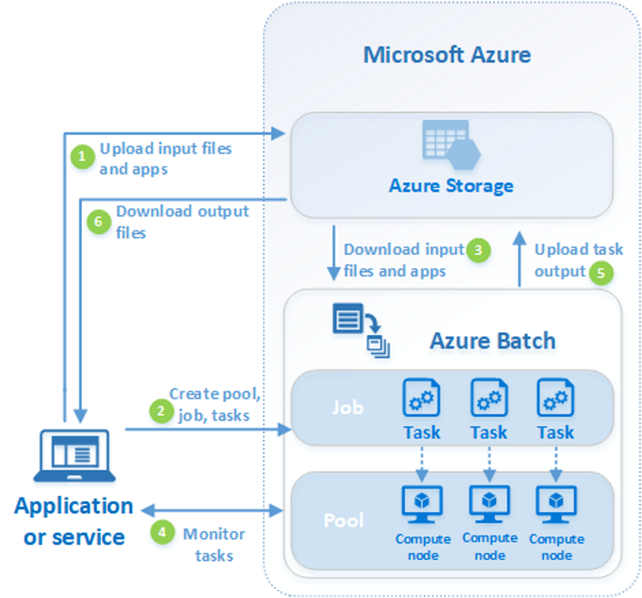

* + High-level architecture components such as User Management, Order Processing, Catalog & Payment Systems.

* + Azure Cosmos DB for globally distributed, low-latency data storage.

We discussed how Azure Storage (Blob, Queue, File) can be leveraged to manage product images, logs, and other data with high availability.

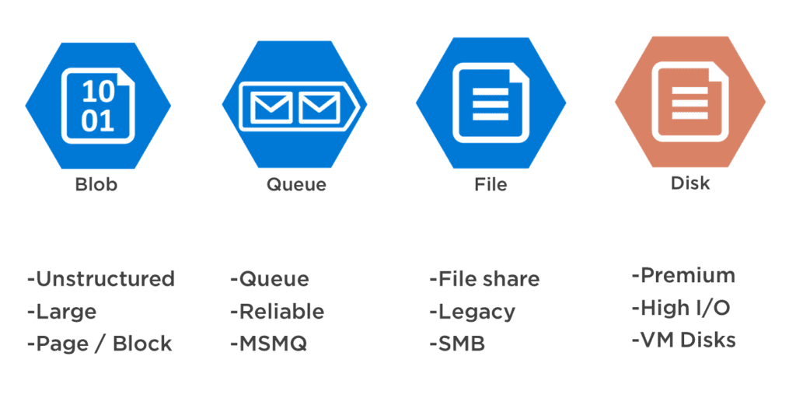

1. AI-Powered Features in E-Commerce: One of the highlights of the workshop was exploring how AI technologies can be seamlessly integrated to enhance e-commerce platforms:
   * Personalized Product Recommendations:  
     With Azure OpenAI and Azure Cognitive Services - Personalizer, I demonstrated how to deliver highly personalized product recommendations based on user behavior and preferences. This helps improve sales and customer engagement by making relevant suggestions in real-time. 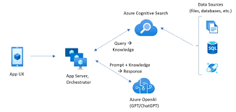
   * AI-Powered Customer Support & Smart Order Processing:  
     Using Azure AI and Computer Vision, I discussed how to automate customer service through chatbots, detect fraudulent activities, and optimize the order fulfilment process. I also covered Azure Cognitive Services for sentiment analysis and language understanding, which enhances the customer support experience.
   * A diagram of a cloud

     Description automatically generated

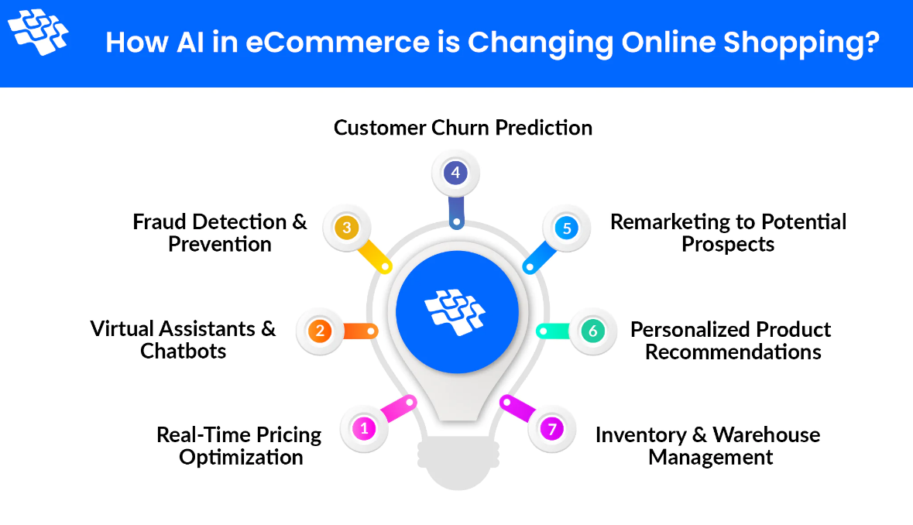

* + Automated Product Categorization & Search Optimization:  
    In a use case where customers struggle to find the right products in large catalogs, I demonstrated the power of Azure Search and Azure OpenAI in enhancing search capabilities. This includes auto-categorizing products and improving search relevance based on natural language queries, providing customers with a seamless search experience.
  + 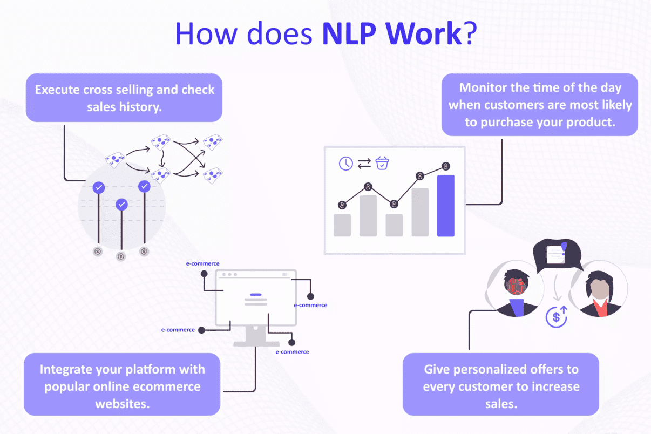
  + 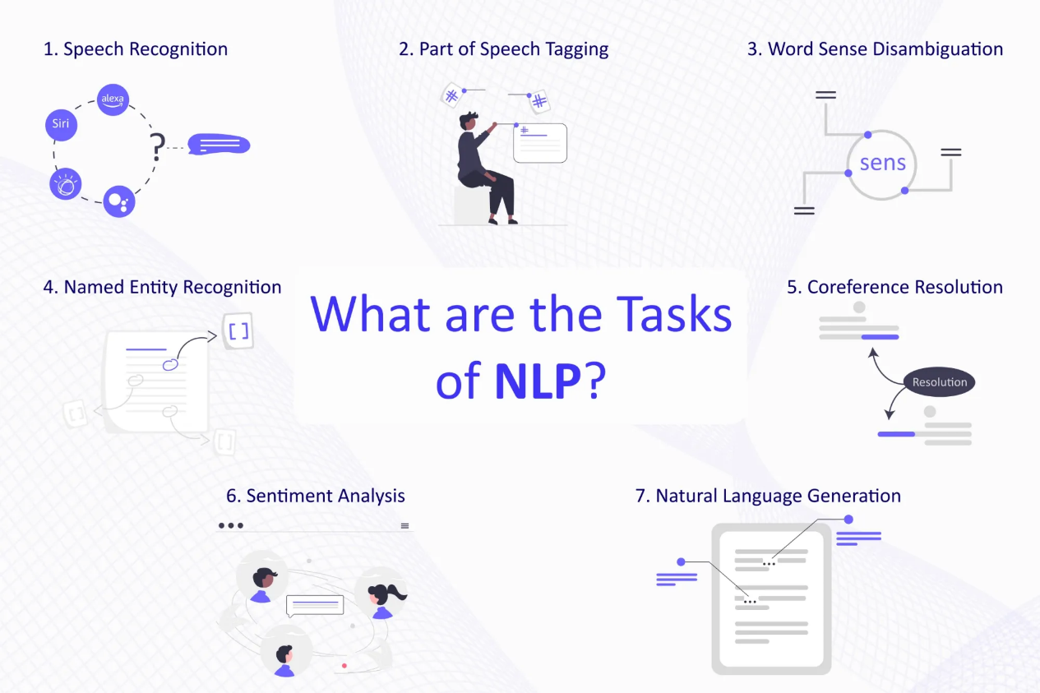

1. AI-Driven Logistics & Delivery Optimization: The next hour focused on optimizing logistics using AI-powered solutions. We discussed:
   * How Azure Maps and Machine Learning can help with AI-driven logistics, route optimization, and delivery tracking.
   * Real-time location tracking and predictive delivery time estimation using Azure’s geospatial capabilities.

|  |
| --- |
| **Azure's Geospatial Capabilities:**  Azure provides several services with geospatial features that can be used for real-time location tracking and predictive delivery time estimation:   1. **Azure Maps**:    * Offers geospatial APIs such as routes, search, and spatial analytics.    * Provides real-time traffic information, which is critical for predictive delivery time.    * Includes spatial data analysis, allowing for advanced capabilities like proximity searches and geofencing. 2. **Azure Functions and Logic Apps**:    * Can integrate with Azure Maps for real-time location tracking and trigger workflows based on location changes.    * Supports event-driven architecture for real-time responses to location data. 3. **Azure Cosmos DB**:    * Supports geospatial indexing, allowing you to store and query geospatial data efficiently.    * Cosmos DB's global distribution and low-latency capabilities are useful for tracking delivery vehicles or items across regions. 4. **Azure Machine Learning**:    * Can be integrated for predictive analytics using historical location data to predict delivery times more accurately.    * Machine learning models can be deployed to forecast delays, estimate travel times, and optimize delivery routes.   **Kafka (Old Approach):**  Kafka is a high-throughput distributed event streaming platform that can be used for real-time data pipelines, including location tracking, but it lacks native geospatial features like Azure. Here's how Kafka could be used:   1. **Real-time Data Streaming**:    * Kafka can stream real-time location data from delivery vehicles or mobile apps using producers and consumers.    * It ensures that location updates are handled in near real-time, with high throughput. 2. **Integration with External Geospatial Services**:    * Kafka can be integrated with external services or databases (e.g., Google Maps, Mapbox, or open-source solutions) to process and enrich location data, though this requires additional effort and integration. 3. **Kafka Streams for Predictive Models**:    * Kafka Streams can be used to process data and apply predictive models (using external machine learning tools) to estimate delivery times.    * However, creating a predictive model from Kafka data would still require using external platforms or custom-built systems for machine learning.   **Comparison:**   * **Ease of Use**: Azure offers integrated services like Azure Maps and Cosmos DB with built-in geospatial and predictive capabilities, which makes it easier to implement real-time tracking and delivery time estimation without much custom setup. * **Scalability**: Kafka is highly scalable and can handle massive streams of data, but adding geospatial features would require more work. Azure services, on the other hand, offer scalability and geospatial features out-of-the-box. * **Predictive Capabilities**: While both Azure and Kafka can be integrated with machine learning models, Azure provides more built-in tools (e.g., Azure ML and Maps) to handle predictive analytics directly. * **Maintenance**: Kafka can be complex to set up and maintain, especially if you're building custom geospatial solutions. Azure simplifies this with its integrated services.   **Conclusion:**  For **real-time location tracking** and **predictive delivery time estimation**, Azure's geospatial services offer a more streamlined and scalable solution with native support for geospatial analytics and predictive features. Kafka, while a robust platform for streaming data, would require additional effort to integrate external geospatial services and machine learning systems. Therefore, Azure is likely the better choice for this specific use case. |

1. AI-Enhanced Seller & Vendor Management: We then moved into optimizing vendor relationships using Azure AI and OpenAI:
   * How AI models can analyze sales data and predict vendor performance, ensuring efficient inventory management and timely deliveries.
   * Using OpenAI to automate communications and streamline vendor negotiation processes based on historical data.
2. AI-Driven Security, Logging & Monitoring: Security and proactive monitoring were crucial topics in the final hour. I shared how to leverage:
   * Azure Sentinel for AI-driven security analytics and threat detection across microservices, providing real-time insights into security incidents.
   * Logging & Monitoring: I demonstrated how to integrate Filebeat, Logstash, and ELK Stack for enhanced log management and visualizations, allowing the team to proactively monitor system health and security in real-time.

Hands-On AI Integration: Use Cases & Challenges

Throughout the workshop, I emphasized the integration of AI capabilities across various parts of the e-commerce architecture:

* AI for Personalization: Demonstrated how Azure Personalizer can enhance user experience by recommending products based on individual preferences and past interactions.
* Fraud Detection & Order Processing: We dove into using Azure Cognitive Services and AI models to flag suspicious transactions and detect anomalies in order processing, ensuring a secure and efficient system.
* Search Optimization with Azure OpenAI: By utilizing Azure OpenAI’s capabilities, we explored the creation of an intelligent product search that adapts based on user feedback and search patterns.
* Logistics and Delivery Optimization: Integrated Azure Maps with Machine Learning models to forecast delivery times and optimize routes, providing a smoother customer experience.

Design Patterns and Best Practices

As we navigated through these AI-driven use cases, I also discussed design patterns such as:

* Event-Driven Architecture: Using Azure Service Bus and Event Grid for decoupling components and ensuring resilience.
* CQRS and Event Sourcing: To ensure data consistency and scalability, especially in scenarios where multiple services need to communicate with minimal latency.
* Retry Policies and Circuit Breaker Patterns: Using Polly to manage failures in distributed systems and maintain high availability.
* API Gateway Patterns: Leveraging Azure API Management for secure API exposure and centralized monitoring.

Conclusion & Looking Ahead

The workshop was a great success, with attendees gaining valuable insights into Azure’s cloud-native capabilities, AI-driven solutions, and advanced architectural patterns. From personalized recommendations to smart order processing, fraud detection, and AI-enhanced logistics, we explored how .NET and Azure Cloud can work together to create innovative, scalable, and efficient e-commerce solutions.

The feedback from participants was extremely positive, and I’m excited to continue sharing my expertise and experience in building cloud-native solutions that not only meet business objectives but also provide transformative experiences for customers.

If you missed the workshop but want to explore how Azure AI, OpenAI, and Cognitive Services can enhance your e-commerce platform, feel free to reach out! I’d be happy to share additional resources or discuss potential collaborations.

Reference:

<https://blog.gopenai.com/analyze-image-with-azure-ai-vision-2884e1fc334d>

**📅 Week 1: Cloud Strategy & Architecture Foundations**

| **Day** | **Topics** | **Tasks & Learning Resources** |
| --- | --- | --- |
| **Day 1** | **Enterprise Architecture & 6R Migration Strategies**  **Rehost -“lift-and-shift.”**  **Retain(“revisit” or do nothing.)**  **Retire("Get rid of old one.") -decide to refactor or repurchase an app.** | 🎥 Watch: [6R Migration Strategies](https://www.youtube.com/watch?v=DEwHplgV36Q)  📖 Read: [Azure Migration Framework](https://learn.microsoft.com/en-us/azure/cloud-adoption-framework/migrate/)  ✅ Hands-on: **Identify 6R strategy for a sample .NET monolith** |
| **Day 2** | **Azure Migrate & Landing Zones** | 🎥 Watch: [Azure Migrate Overview](https://www.youtube.com/watch?v=9D7wo4f-Y80)  📖 Read: [Azure Landing Zones](https://learn.microsoft.com/en-us/azure/cloud-adoption-framework/ready/landing-zone/)  ✅ Hands-on: **Set up an Azure Migrate project in the portal** |
| **Day 3** | **Governance Best Practices & Cost Analysis** | 📖 Read: [Azure Cost Management Best Practices](https://learn.microsoft.com/en-us/azure/cost-management-billing/costs/)  ✅ Hands-on: **Estimate cloud costs using Azure Pricing Calculator** |
| **Day 4** | **Hybrid Connectivity (Azure Arc, ExpressRoute, VPN)** | 🎥 Watch: [Azure Arc Overview](https://www.youtube.com/watch?v=y2FrirDXjfs)  📖 Read: [ExpressRoute vs. VPN Gateway](https://learn.microsoft.com/en-us/azure/expressroute/expressroute-faqs) |
| **Day 5** | **Hybrid Identity with Azure AD Connect** | 🎥 Watch: [Azure AD Connect Deep Dive](https://www.youtube.com/watch?v=kF72xHySx48)  ✅ Hands-on: **Simulate a hybrid AD setup in Azure Portal** |
| **Day 6** | **Review & Mock Q/A on Strategy & Governance** | ✅ **Mock Interview:** Explain **6R Migration & Azure Migrate** in 5 mins |
| **Day 7** | **Presentation Practice – Cloud Strategy Roadmap** | 🎤 Create a **3-slide presentation** on “Modernizing a .NET App to Azure” |

**📅 Week 2: Security & Compliance**

| **Day** | **Topics** | **Tasks & Learning Resources** |
| --- | --- | --- |
| **Day 8** | **Azure Security Center & Defender for Cloud** | 🎥 Watch: [Defender for Cloud](https://www.youtube.com/watch?v=baQSlB1nLB8)  ✅ Hands-on: **Set up Security Center in an Azure subscription** |
| **Day 9** | **Azure AD, RBAC & Encryption** | 📖 Read: [RBAC in Azure](https://learn.microsoft.com/en-us/azure/role-based-access-control/)  ✅ Hands-on: **Create RBAC roles in Azure Portal** |
| **Day 10** | **Compliance (GDPR, ISO 27001, SOC 2)** | 🎥 Watch: [GDPR in Azure](https://www.youtube.com/watch?v=oyO9JJW65HU)  ✅ Hands-on: **Check compliance in Defender for Cloud** |
| **Day 11** | **Risk Management & Threat Modeling (STRIDE)** | 📖 Read: STRIDE Model  ✅ Hands-on: **Create a simple STRIDE threat model for a web app** |
| **Day 12** | **Azure Key Vault & Secrets Management** | 🎥 Watch: [Azure Key Vault Tutorial](https://www.youtube.com/watch?v=mXe48pn6cGE)  ✅ Hands-on: **Store & retrieve a secret in Key Vault** |
| **Day 13** | **Review & Mock Q/A on Security & Compliance** | ✅ **Mock Interview:** Explain **Azure Security Center & Compliance** in 5 mins |
| **Day 14** | **Presentation Practice – Cloud Security Strategy** | 🎤 Create a **3-slide presentation** on **Azure Security Architecture** |

**📅 Week 3: Architecture, Scalability & Optimization**

| **Day** | **Topics** | **Tasks & Learning Resources** |
| --- | --- | --- |
| **Day 15** | **Azure Well-Architected Framework (WAF)** | 📖 Read: [WAF Overview](https://learn.microsoft.com/en-us/azure/architecture/framework/)  ✅ Hands-on: **Assess an existing solution using WAF pillars** |
| **Day 16** | **Business Alignment & IT Strategy** | 🎥 Watch: [IT Strategy for Architects](https://www.youtube.com/watch?v=CrMjQjCFI-8)  ✅ Hands-on: **Draft an IT strategy doc aligning with business goals** |
| **Day 17** | **Scalability & Performance Optimization** | 🎥 Watch: [Azure Auto-scaling](https://www.youtube.com/watch?v=6aE_oX9_m9A)  ✅ Hands-on: **Set up auto-scaling for an Azure App Service** |
| **Day 18** | **Cost Optimization & FinOps** | 📖 Read: [Azure Cost Optimization Guide](https://learn.microsoft.com/en-us/azure/cloud-adoption-framework/strategy/cloud-cost-optimization)  ✅ Hands-on: **Optimize a workload using reserved instances & Spot VMs** |
| **Day 19** | **Review & Mock Q/A on Architecture & Optimization** | ✅ **Mock Interview:** Explain **scalability & cost optimization in Azure** |
| **Day 20** | **Presentation Practice – Scalable Cloud Architecture** | 🎤 Create a **3-slide presentation** on **a scalable cloud solution** |

**📅 Week 4: Final Preparation & Mock Interviews**

| **Day** | **Topics** | **Tasks & Learning Resources** |
| --- | --- | --- |
| **Day 21** | **Cloud Migration & Modernization Strategy** | ✅ **Practice:** Explain **Cloud Migration Strategy** in **3 mins** |
| **Day 22** | **Security & Compliance Review** | ✅ **Practice:** Explain **Azure Security & Risk Management** in **3 mins** |
| **Day 23** | **Cost Optimization & FinOps Review** | ✅ **Practice:** Justify cost savings in a **real-world scenario** |
| **Day 24** | **Scalability & Resilience Deep Dive** | ✅ **Mock Q/A:** Compare **Active-Active vs. Active-Passive** |
| **Day 25** | **Final Mock Interviews (Technical + Executive)** | 🎤 Simulate **a real EA interview** with a mentor/friend |
| **Day 26** | **Presentation Skills Polishing** | 🎤 Practice **a 5-min executive presentation** |
| **Day 27** | **Case Study – End-to-End Architecture** | ✅ Prepare **a 10-min case study on modernizing a .NET app to Azure** |
| **Day 28** | **Final Review & Confidence Boosting** | 🎤 **Summarize learnings & key takeaways** |

**🚀 How to Stay on Track?**

* **Spend 1 hour daily** on learning & hands-on practice.
* **Record yourself explaining concepts** & improve clarity.
* **Use AI tools (ChatGPT) to rehearse answers**.
* **Present to a friend or in front of a mirror**.

This plan ensures you **improve both technical & communication skills** within a month.  
Would you like **mock interview questions & answers** or **presentation templates** next? 🚀

4o

**Applying the 6R Migration Strategies**

| **Strategy** | **Example for .NET E-Commerce App** | **When to Choose?** |
| --- | --- | --- |
| **Rehost ("Lift and Shift")** | Move the **existing .NET app** as-is to an **Azure Virtual Machine (VM)** running IIS and SQL Server. | ✅ **Fast migration** with minimal changes  ❌ **No cloud benefits like auto-scaling** |
| **Refactor ("Replatform")** | Move the app to **Azure App Service** instead of a VM, while keeping the **SQL Server in Azure SQL Managed Instance**. | ✅ **Some cloud benefits (scalability, managed services)**  ❌ **Still a monolith, limited improvements** |
| **Rearchitect** | Break the monolith into **microservices** using **ASP.NET Core** and deploy them to **Azure Kubernetes Service (AKS)**. | ✅ **Better scalability & cloud-native benefits**  ❌ **Time-consuming & costly** |
| **Rebuild** | Completely rewrite the application using **.NET 8 + Blazor** with a **serverless backend in Azure Functions + Cosmos DB**. | ✅ **Best for long-term innovation**  ❌ **High development effort** |
| **Replace** | Replace the **custom-built e-commerce** app with **Shopify, Magento, or Azure Commerce Services**. | ✅ **Best if a SaaS solution meets business needs**  ❌ **May lose customization** |
| **Retire** | Remove **unused modules** like an outdated **customer support feature**, replacing it with **Zendesk or Freshdesk SaaS**. | ✅ **Reduces maintenance costs** |

**Applying the 6R Strategy**

| **Strategy** | **Explanation** | **Example Implementation** |
| --- | --- | --- |
| **1. Rehost (Lift-and-Shift)** | Move workloads **as-is** to the cloud without changes. | ✅ Migrate the **.NET MVC app** to an **Azure Virtual Machine** (Windows Server).  ✅ Use **Azure SQL Managed Instance** instead of on-prem SQL Server. |
| **2. Refactor (Repackage)** | Make minor code/configuration changes without modifying the architecture. | ✅ Move the **.NET MVC app** to **Azure App Service** (PaaS).  ✅ Store images in **Azure Blob Storage** instead of local file storage. |
| **3. Rearchitect** | Redesign the application to be cloud-native. | ✅ Break monolithic **MVC app** into **Microservices (Web API + Angular frontend)**.  ✅ Use **Azure Kubernetes Service (AKS)** for containerized deployment.  ✅ Replace SQL Server with **Azure Cosmos DB** for scalability. |
| **4. Rebuild** | Rewrite the application from scratch using modern cloud technologies. | ✅ Develop a **new serverless e-commerce app** using **Azure Functions, Logic Apps, and Event Grid**.  ✅ Use **Power Platform for low-code backend processing**. |
| **5. Replace** | Switch to a completely different SaaS solution. | ✅ Instead of maintaining a custom-built system, use **Shopify, Salesforce Commerce, or Azure Marketplace SaaS solutions**. |
| **6. Retire** | Decommission unused applications or services. | ✅ Remove the **legacy payment gateway** and replace it with **Azure Payment Services (Stripe, Razorpay, etc.)**. |

**Applying WAF Pillars**

| **Pillar** | **Challenges** | **Solution (Azure Services & Best Practices)** |
| --- | --- | --- |
| **🔹 Reliability (High Availability & DR)** | - Single data center failure risk  - Manual failover & backups | ✅ **Active-Active Multi-Region Deployment** using **Azure Front Door** and **Azure Traffic Manager**  ✅ **Database Geo-Replication** with **Azure SQL Failover Group**  ✅ **Azure Backup & Site Recovery** for disaster recovery |
| **💰 Cost Optimization** | - High infrastructure costs  - Unused resources running 24/7 | ✅ **Azure App Service (PaaS)** instead of VMs to reduce maintenance overhead  ✅ **Azure Reserved Instances** for cost savings  ✅ **Auto-scaling based on demand** (Scale-out during sales events) |
| **⚙️ Operational Excellence** | - Manual deployments causing delays  - No visibility into performance issues | ✅ **CI/CD using Azure DevOps Pipelines** for automated deployments  ✅ **Infrastructure as Code (Terraform/ARM templates)** for repeatable setups  ✅ **Azure Monitor + Application Insights** for proactive alerts |
| **🔐 Security & Compliance** | - Weak authentication  - No centralized identity management  - Compliance risks (PCI-DSS, GDPR) | ✅ **Azure AD with MFA & Conditional Access**  ✅ **RBAC & Key Vault for secure access control**  ✅ **Microsoft Defender for Cloud & Sentinel for threat monitoring** |
| **⚡ Performance Efficiency** | - Slow page load times  - High latency for global users | ✅ **Azure Front Door + CDN** to improve load times  ✅ **Azure Redis Cache for session management**  ✅ **Read Replicas & Indexing for SQL performance optimization** |

Azure CAF’s Six Phases → Strategy, Plan, Ready, Adopt, Govern, Manage

**Azure Cloud Adoption Framework (CAF) – Migration Strategy**

The **Azure Cloud Adoption Framework (CAF)** provides best practices, tools, and methodologies to **migrate workloads** from **on-premise or other clouds to Azure** efficiently.

**📌 Key Phases of Azure Migration Framework**

Azure CAF divides migration into **six structured phases**:

| **Phase** | **Objective** | **Key Activities** | **Azure Services & Tools** |
| --- | --- | --- | --- |
| **1️⃣ Strategy** | Define business goals & cloud adoption roadmap | ✅ Identify business drivers & outcomes  ✅ Define key migration KPIs (cost, scalability, performance) | 🔹 Azure Migrate  🔹 Total Cost of Ownership (TCO) Calculator |
| **2️⃣ Plan** | Assess current IT landscape & migration approach | ✅ Inventory workloads & dependencies  ✅ Select a **6R migration strategy** (Rehost, Refactor, Rearchitect, Rebuild, Replace, Retire) | 🔹 Azure Migrate  🔹 Azure TCO Calculator |
| **3️⃣ Ready** | Prepare Azure landing zone & governance | ✅ Set up **Landing Zones** (Networking, IAM, Policies)  ✅ Implement **Security & Compliance** (RBAC, IAM, Defender for Cloud) | 🔹 Azure Landing Zone  🔹 Azure Arc  🔹 Azure ExpressRoute/VPN Gateway |
| **4️⃣ Adopt (Migrate & Modernize)** | Migrate workloads to Azure & optimize | ✅ Migrate workloads using **Azure Migrate**  ✅ Modernize apps with **Azure App Service, AKS, or Functions** | 🔹 Azure Migrate  🔹 Azure Database Migration Service  🔹 Azure App Service |
| **5️⃣ Govern** | Establish cloud governance, policies & compliance | ✅ Implement **RBAC, cost policies, tagging, compliance (ISO 27001, GDPR)**  ✅ Monitor security posture with **Defender for Cloud** | 🔹 Azure Policy  🔹 Microsoft Defender for Cloud |
| **6️⃣ Manage** | Optimize, monitor, and secure workloads post-migration | ✅ Implement **Azure Monitor & Log Analytics**  ✅ Set up **Cost Management & Auto-scaling** | 🔹 Azure Monitor  🔹 Azure Cost Management |

**📌 6R Migration Strategy in Azure**

Azure supports **six common migration approaches**, depending on **business goals and technical feasibility**:

| **Strategy** | **Description** | **Example in .NET Migration** |
| --- | --- | --- |
| **1️⃣ Rehost (Lift-and-Shift)** | Move apps to Azure **without changes** | ✅ Move **.NET MVC app** to an **Azure VM** with SQL Server |
| **2️⃣ Refactor (Repackage)** | Minor **code/configuration changes** for PaaS benefits | ✅ Host **.NET API on Azure App Service**, store files in **Azure Blob** |
| **3️⃣ Rearchitect** | Convert monolith to **microservices/cloud-native** | ✅ Break **.NET MVC app into Web API + Angular frontend** on **AKS** |
| **4️⃣ Rebuild** | Rewrite the app using **modern serverless/cloud technologies** | ✅ Develop a **new e-commerce app using Azure Functions & Cosmos DB** |
| **5️⃣ Replace** | Replace with **SaaS solution** | ✅ Use **Shopify, Dynamics 365 Commerce instead of custom .NET app** |
| **6️⃣ Retire** | Decommission unnecessary services | ✅ Remove **legacy FTP-based product catalog sync** |

**📌 Azure Landing Zone (Pre-Migration Setup)**

Before migrating, set up an **Azure Landing Zone** to standardize **networking, security, governance, and compliance**.

| **Component** | **Best Practice** | **Azure Service** |
| --- | --- | --- |
| **Identity & Access Management** | Use **Azure AD, RBAC, Conditional Access** | 🔹 Azure AD  🔹 Privileged Identity Management |
| **Networking** | **Hub-Spoke architecture, VPN, ExpressRoute** for hybrid connectivity | 🔹 Azure Virtual Network  🔹 ExpressRoute/VPN Gateway |
| **Security & Compliance** | **Zero Trust, Encryption, Defender for Cloud** | 🔹 Microsoft Defender for Cloud  🔹 Azure Key Vault |
| **Monitoring & Governance** | **Azure Monitor, Policy, Log Analytics** | 🔹 Azure Policy  🔹 Azure Monitor  🔹 Azure Security Center |

**📌 Migration Process: Step-by-Step**

| **Step** | **Task** | **Azure Services/Tools** |
| --- | --- | --- |
| **1️⃣ Discover & Assess** | Identify workloads, dependencies, and sizing | 🔹 Azure Migrate  🔹 Service Map |
| **2️⃣ Design** | Select the **6R strategy**, define landing zone | 🔹 Azure TCO Calculator  🔹 Azure Landing Zone |
| **3️⃣ Migrate** | Move workloads using **Azure Migrate & DMS** | 🔹 Azure Migrate  🔹 Database Migration Service (DMS) |
| **4️⃣ Optimize & Secure** | Fine-tune for cost & security compliance | 🔹 Azure Monitor  🔹 Microsoft Defender for Cloud |
| **5️⃣ Manage & Automate** | Implement governance, FinOps, and monitoring | 🔹 Azure Policy  🔹 Log Analytics  🔹 Cost Management |

**📌 Example: Migrating a .NET-Based E-Commerce App to Azure**

**🚀 Scenario:**

* **Current Setup:** On-premises **.NET MVC e-commerce app with SQL Server**
* **Goal:** Improve **scalability, security, and cost-efficiency**

**🔹 Migration Approach:**

| **Component** | **Migration Strategy** | **Azure Service Used** |
| --- | --- | --- |
| **Web App (ASP.NET MVC)** | **Refactor** | ✅ Migrate to **Azure App Service** |
| **SQL Server** | **Rehost** | ✅ Use **Azure SQL Managed Instance** |
| **File Storage** | **Refactor** | ✅ Move to **Azure Blob Storage** |
| **Authentication** | **Rearchitect** | ✅ Integrate with **Azure AD B2C** |
| **Caching** | **Rearchitect** | ✅ Implement **Azure Redis Cache** |
| **Monitoring** | **Optimize** | ✅ Enable **Application Insights** |

**🎯 Outcome After Migration**

| **Before Migration (On-Premise)** | **After Migration to Azure** |
| --- | --- |
| ❌ High infra cost & maintenance | ✅ Cost savings with **Azure App Service + Auto-Scaling** |
| ❌ Single data center risk | ✅ **Multi-region HA with Azure Front Door** |
| ❌ No real-time monitoring | ✅ **Azure Monitor + Log Analytics for insights** |
| ❌ Manual deployments | ✅ **CI/CD with Azure DevOps Pipelines** |

**✅ Summary:**

1️⃣ **Follow Azure CAF’s Six Phases** → Strategy, Plan, Ready, Adopt, Govern, Manage  
2️⃣ **Choose the Right Migration Strategy** (Rehost, Refactor, Rearchitect, Rebuild, Replace, Retire)  
3️⃣ **Use Azure Landing Zone** for best practices in governance & security  
4️⃣ **Migrate in Phases** using **Azure Migrate & Database Migration Service**  
5️⃣ **Optimize & Secure** with **Azure Monitor, Cost Management, Defender for Cloud**

<https://cloudavenue.in/cloudavenue-architecture-center-2/azure-web-app/>

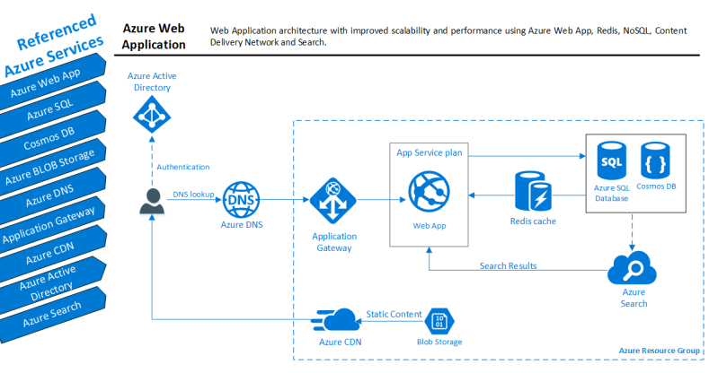

Multi region example

<https://learn.microsoft.com/en-us/azure/architecture/web-apps/guides/enterprise-app-patterns/reliable-web-app/dotnet/guidance>

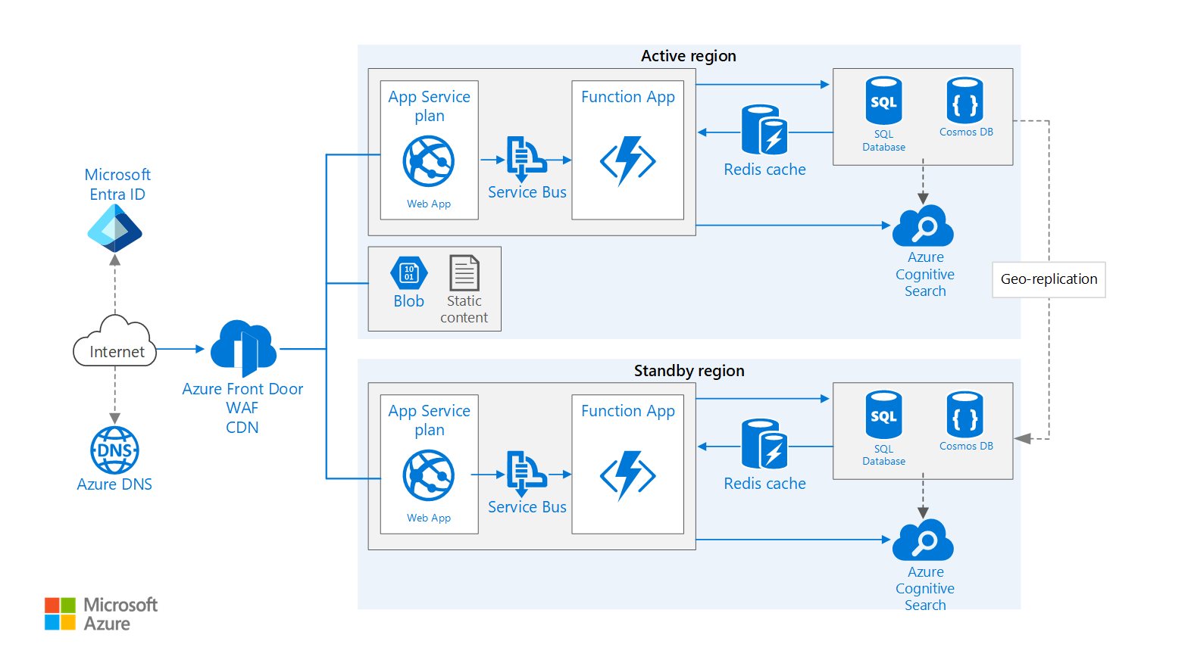

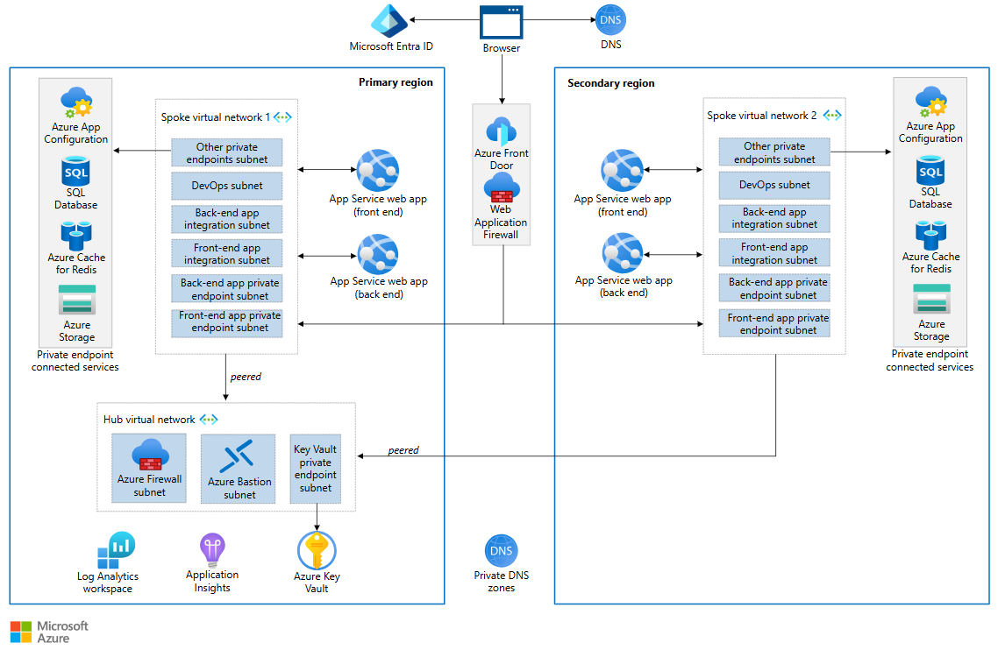

<https://learn.microsoft.com/en-us/azure/architecture/web-apps/guides/enterprise-app-patterns/reliable-web-app/dotnet/guidance>

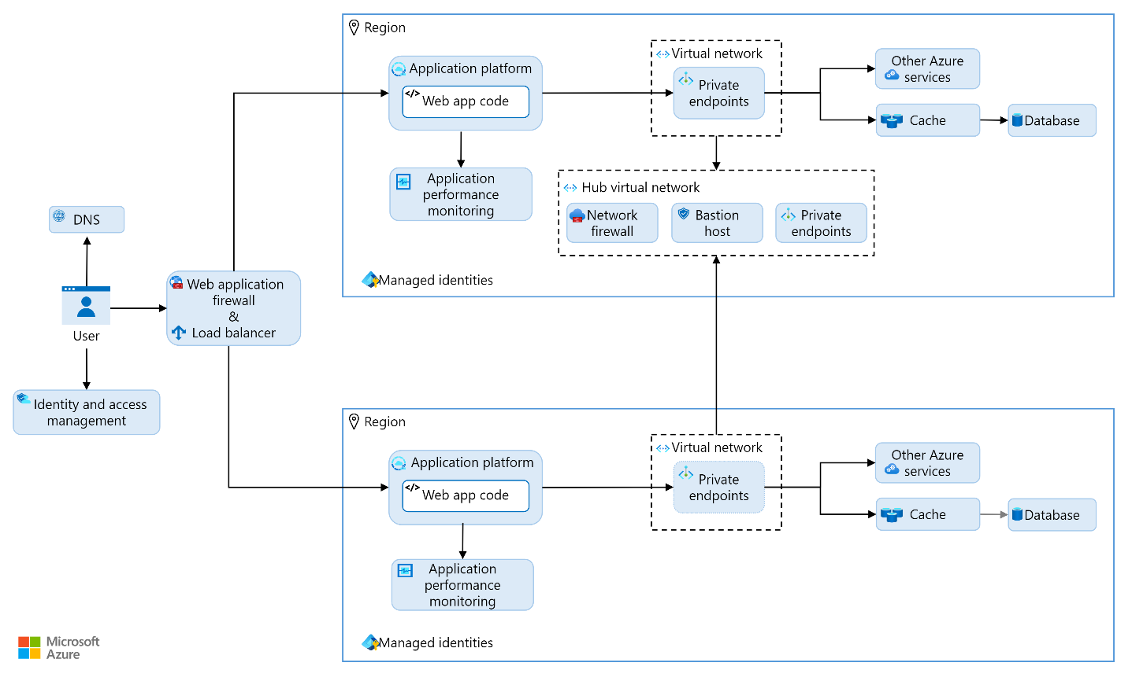

**How to implement the Reliable Web App pattern**

[**https://learn.microsoft.com/en-us/azure/architecture/web-apps/guides/enterprise-app-patterns/reliable-web-app/dotnet/guidance**](https://learn.microsoft.com/en-us/azure/architecture/web-apps/guides/enterprise-app-patterns/reliable-web-app/dotnet/guidance)

* Apply low-cost, high-value code changes.
* Reach an SLO of 99.9%.
* Adopt DevOps practices.
* Create cost-optimized environments.
* Improve reliability and security.